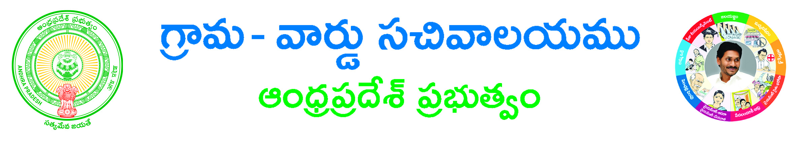

***Issue of GNM Marks Memo (I/ II / III year)***

Hall ticket No___________________________

Select Year (I/II/III) ____________________

Do you want name/Father name change (If displayed name with spelling mistakes) Yes No

If Yes Name _______________________________

Father Name ______________________________

***Applicant details***

Applicant Name _____________________

Father/Husband Name____________________

District ____________________________

Mandal _______________________________

Village ____________________________

Pin Code ___________________________

Email Id ___________________________

Mobile No ______________________________

Relationship ___________________________